Activity 1.1.5 - Run Robot, Run

Kyle Huang - CSP Period 5

9/8/21

[Link to Google Drive folder with files](https://drive.google.com/drive/folders/1YDLJjVVxNcXKcFs6eEMOZUS4npgGlLXN?usp=sharing)

Code:

| # a115_robot_maze.py  import turtle as trtl  import time  #----- maze and turtle config variables  screen_h = 400  screen_w = 420  startx = -100  starty = -100  turtle_scale = 1.5  #------ robot commands  def move():  robot.dot(10)  robot.fd(50)  def turn_left():  robot.speed(0)  robot.lt(90)  robot.speed(2)  #----- init screen  wn = trtl.Screen()  wn.setup(width=screen_w, height=screen_h)  robot_image = "robot.gif"  wn.addshape(robot_image)  #----- init robot  robot = trtl.Turtle(shape=robot_image)  robot.hideturtle()  robot.color("darkorchid")  robot.pencolor("darkorchid")  robot.penup()  robot.setheading(90)  robot.turtlesize(turtle_scale, turtle_scale)  robot.goto(startx, starty)  robot.speed(2)  robot.showturtle()  #initial setup  wn.bgpic("maze1.png")  #maze 1 path 1  for i in range(4):  for j in range(3):  turn_left()  move()  turn_left()  move()  #reset/change to maze 2  wn.bgpic("maze2.png")  robot.clear()  robot.goto(startx,starty)  #maze 2 path 1  for i in range(3):  move()  for i in range(3):  turn_left()  for i in range(2):  move()  #reset  robot.clear()  robot.goto(startx,starty)  turn_left()  #maze 2 path 2  for i in range(3):  turn_left()  for i in range(2):  for j in range(3):  move()  turn_left()  move()  #reset/change to maze 3  wn.bgpic("maze3.png")  robot.clear()  robot.goto(startx,starty)  for i in range(3):  turn_left()  robot.goto(startx,starty)  #maze 3 path 1  for i in range(4):  move()  for j in range(3):  turn_left()  move()  turn_left()  #reset/change to custom maze  wn.bgpic("custommaze.png")  robot.clear()  robot.goto(startx,starty)  #custom maze path 1  for i in range(3):  turn_left()  for i in range(2):  turn_left()  for j in range(2):  for k in range(2):  move()  for k in range(3):  turn_left()  turn_left()  wn.mainloop() |
| --- |

Maze 1:

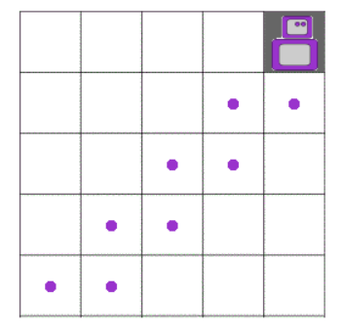

Maze 2 Path 1:

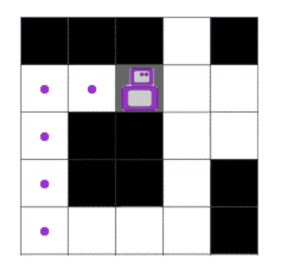

Maze 2 Path 2:

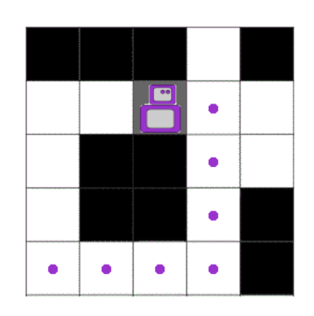

Maze 3:

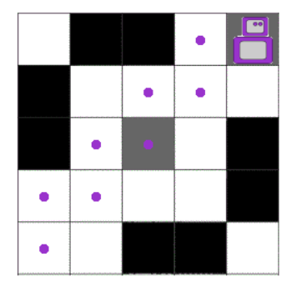

Custom Maze (extra credit maze):

